**Normalization:**

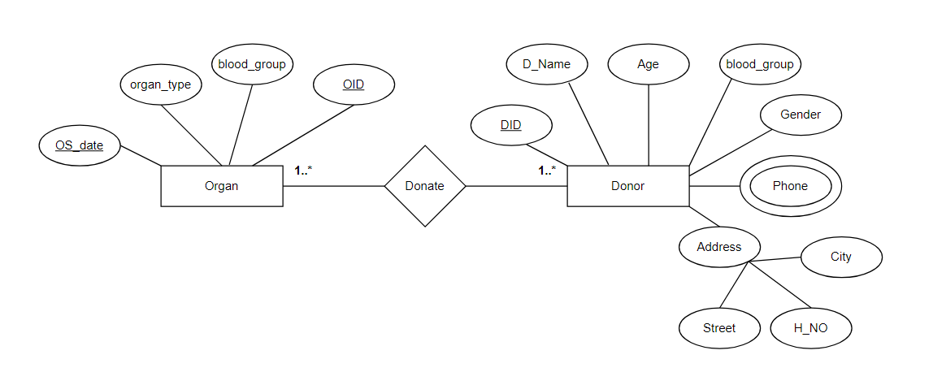

**Donate:**

UNF:

DID, D_NAME, AGE, BLOOD_GROUP, GENDER, PHONE, H_NO, STREET, CITY, OID, BLOOD_GROUP, ORGAN_TYPE, OS_DATE

1NF: PHONE is a multivalued attribute.

DID, D_NAME, AGE, BLOOD_GROUP, GENDER, H_NO, STREET, CITY, OID, BLOOD_GROUP, ORGAN_TYPE, OS_DATE

2NF:

1. DID, D_NAME, AGE, GENDER, H_NO, STREET, CITY, OID
2. DID, BLOOD_GROUP, OID
3. DID, PHONE
4. OID, ORGAN_TYPE, OS_DATE

3NF:

1. DID, D_NAME, AGE, GENDER
2. DID, BLOOD_GROUP, OID
3. DID, PHONE
4. OID, ORGAN_TYPE, OS_DATE
5. DID, H_NO, STREET, CITY

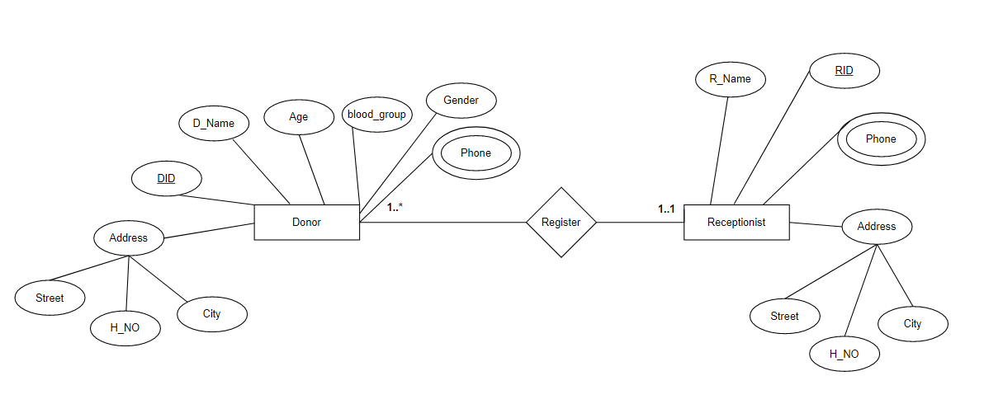

**Register:**

UNF:

DID, D_NAME, AGE, BLOOD_GROUP, GENDER, PHONE, H_NO, STREET, CITY, RID, R_NAME, PHONE, H_NO, STREET, CITY

1NF: PHONE is a multivalued attribute.

DID, D_NAME, AGE, BLOOD_GROUP, GENDER, H_NO, STREET, CITY, RID, R_NAME, H_NO, STREET, CITY

2NF:

1. DID, D_NAME, AGE, BLOOD_GROUP, GENDER, H_NO, STREET, CITY, RID
2. DID, PHONE
3. RID, R_NAME

3NF:

1. DID, D_NAME, AGE, BLOOD_GROUP, GENDER, RID
2. DID, PHONE
3. DID, H_NO, STREET, CITY, RID
4. RID, R_NAME

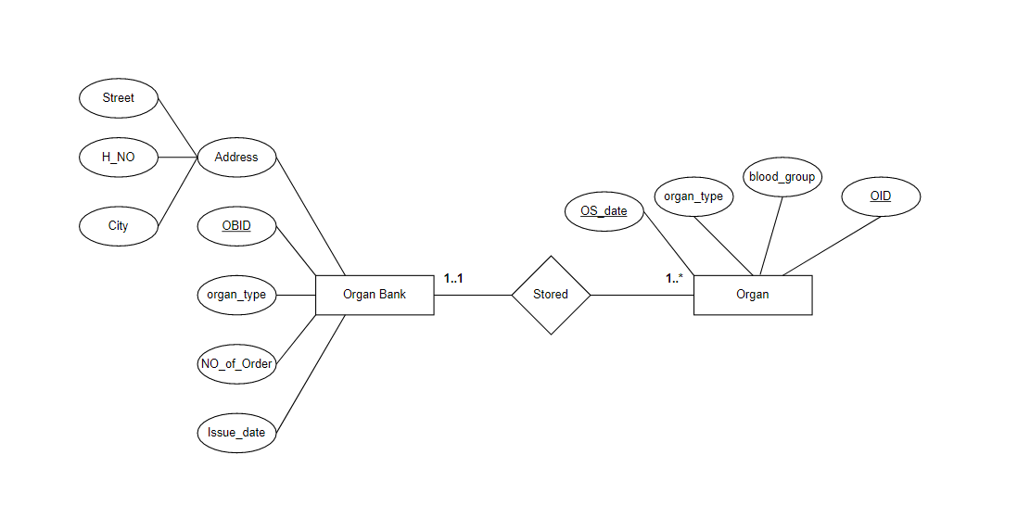

**Stored:**

UNF:

OID, BLOOD_GROUP, ORGAN_TYPE, OS_DATE, OBID, ORGAN_TYPE, NO_OF_ORDER, ISSUE_DATE, H_NO, STREET, CITY

1NF: PHONE is a multivalued attribute.

OID, BLOOD_GROUP, ORGAN_TYPE, OS_DATE, OBID, ORGAN_TYPE, NO_OF_ORDER, ISSUE_DATE, H_NO, STREET, CITY

2NF:

1. OID, BLOOD_GROUP, OS_DATE, OBID
2. OID, ORGAN_TYPE, OBID
3. OBID, NO_OF_ORDER, ISSUE_DATE, H_NO, STREET, CITY

3NF:

1. OID, BLOOD_GROUP, OS_DATE, OBID
2. OID, ORGAN_TYPE, OBID
3. OID, H_NO, STREET, CITY
4. OBID, NO_OF_ORDER, ISSUE_DATE

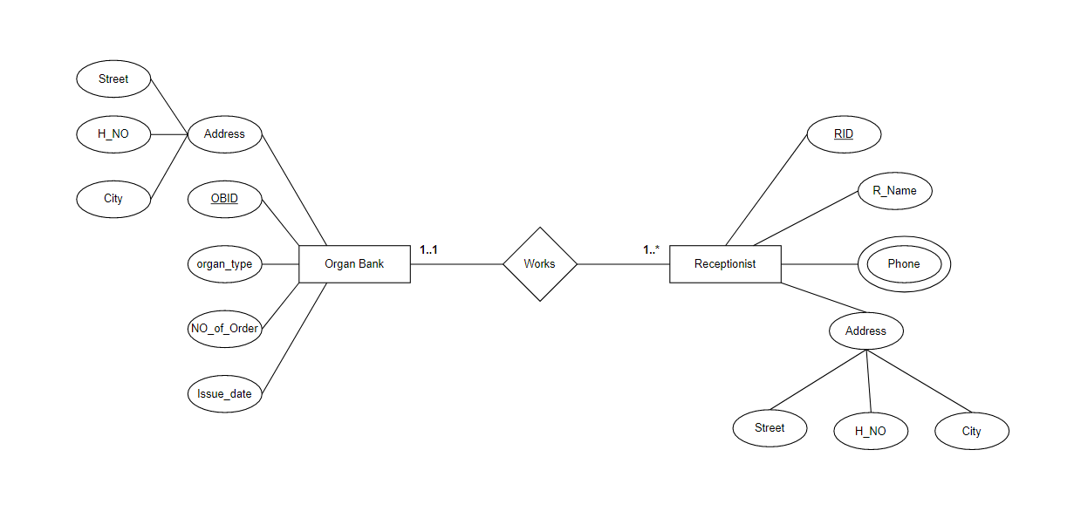

**Works:**

UNF:

OBID, ORGAN_TYPE, NO_OF_ORDER, ISSUE_DATE, H_NO, STREET, CITY, RID, R_NAME, PHONE, H_NO, STREET, CITY

1NF: PHONE is a multivalued attribute.

OBID, ORGAN_TYPE, NO_OF_ORDER, ISSUE_DATE, H_NO, STREET, CITY, RID, R_NAME, H_NO, STREET, CITY

2NF:

1. RID, R_NAME, H_NO, STREET, CITY, OBID
2. RID, PHONE
3. OBID, ORGAN_TYPE, NO_OF_ORDER, ISSUE_DATE

3NF:

1. RID, R_NAME
2. RID, PHONE
3. RID, H_NO, STREET, CITY, OBID
4. OBID, ORGAN_TYPE, NO_OF_ORDER, ISSUE_DATE

**Orders:**

UNF:

OBID, ORGAN_TYPE, NO_OF_ORDER, ISSUE_DATE, H_NO, STREET, CITY, HID, H_NAME, PHONE, H_NO, STREET, CITY

1NF: PHONE is a multivalued attribute.

OBID, ORGAN_TYPE, NO_OF_ORDER, ISSUE_DATE, H_NO, STREET, CITY, HID, H_NAME, H_NO, STREET, CITY

2NF:

1. HID, H_NAME, H_NO, STREET, CITY, OBID
2. HID, PHONE
3. OBID, ORGAN_TYPE, NO_OF_ORDER, ISSUE_DATE

3NF:

1. HID, H_NAME
2. HID, PHONE
3. HID, H_NO, STREET, CITY, OBID
4. OBID, ORGAN_TYPE, NO_OF_ORDER, ISSUE_DATE

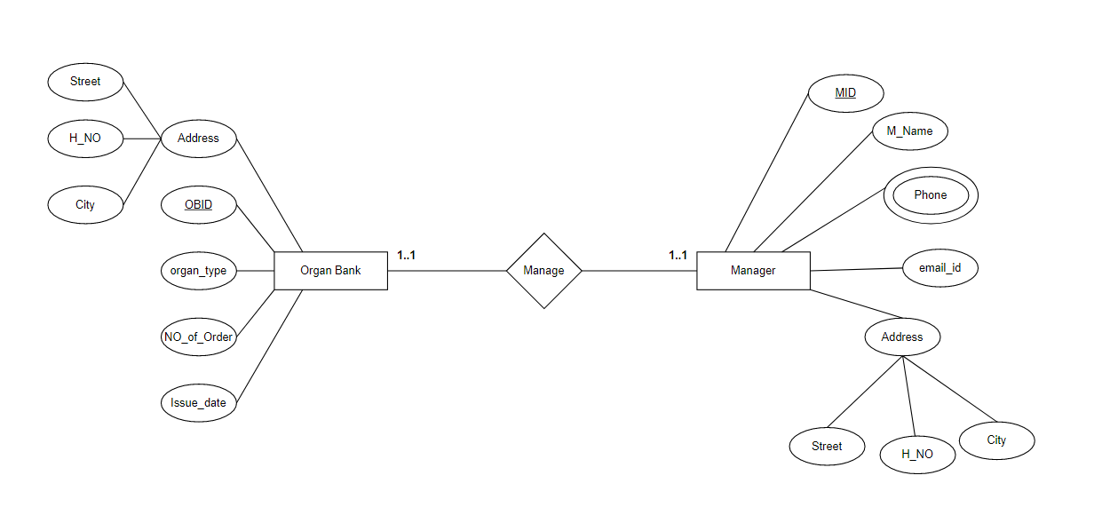

**Manage:**

UNF:

OBID, ORGAN_TYPE, NO_OF_ORDER, ISSUE_DATE, H_NO, STREET, CITY, MID, M_NAME, EMAIL_ID, PHONE, H_NO, STREET, CITY

1NF: PHONE is a multivalued attribute.

OBID, ORGAN_TYPE, NO_OF_ORDER, ISSUE_DATE, H_NO, STREET, CITY, MID, M_NAME, EMAIL_ID, H_NO, STREET, CITY

2NF:

1. MID, M_NAME, EMAIL_ID, H_NO, STREET, CITY, OBID
2. MID, PHONE
3. OBID, ORGAN_TYPE, NO_OF_ORDER, ISSUE_DATE

3NF:

1. MID, M_NAME, EMAIL_ID
2. MID, PHONE
3. MID, H_NO, STREET, CITY, OBID
4. OBID, ORGAN_TYPE, NO_OF_ORDER, ISSUE_DATE